NAAN MUDHAVAN ASSIGNMENT DOCUMENT

**COURSE TITLE** : DIGITAL MARKETING

**COLLEGE CODE** 1105

**COLLEGE NAME** : GOJAN SCHOOL OF BUSINESS AND TECHNOLOGY

**NM ID** : 7492A510F88050D9841493828D11A812

**NAME** : RAMYA R

**REGISTER NUMBER** 110520106013

**YEAR** : 4TH YEAR

**DEPARTMENT** : ELECTRONICS AND COMMUNICATION ENGINEERING

1. Create a blog or website using Blogspot and Wordpress. Customize the theme design and post new article with 500 words.

Link: [https://](https://computerzzzworld.blogspot.com/2023/08/computerz-world-services.html)rmrsartstudio.blogspot.com/2023/10/rmrs-art-studio.html

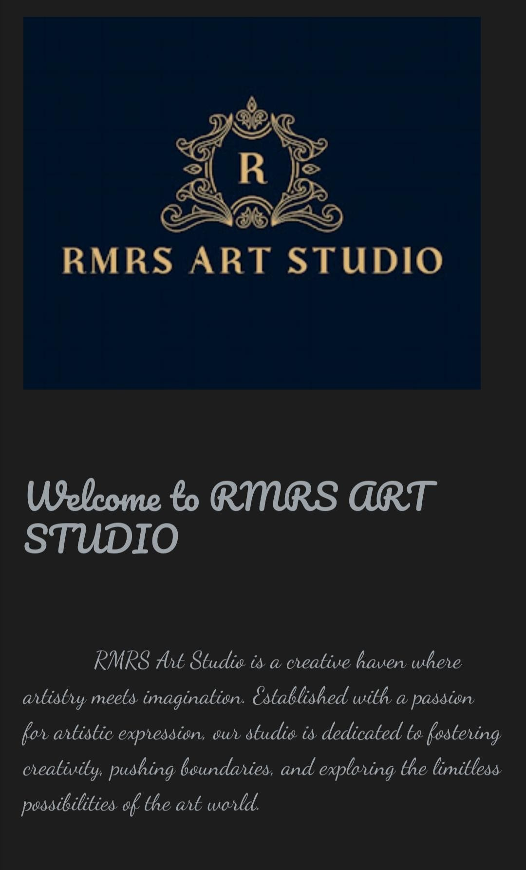

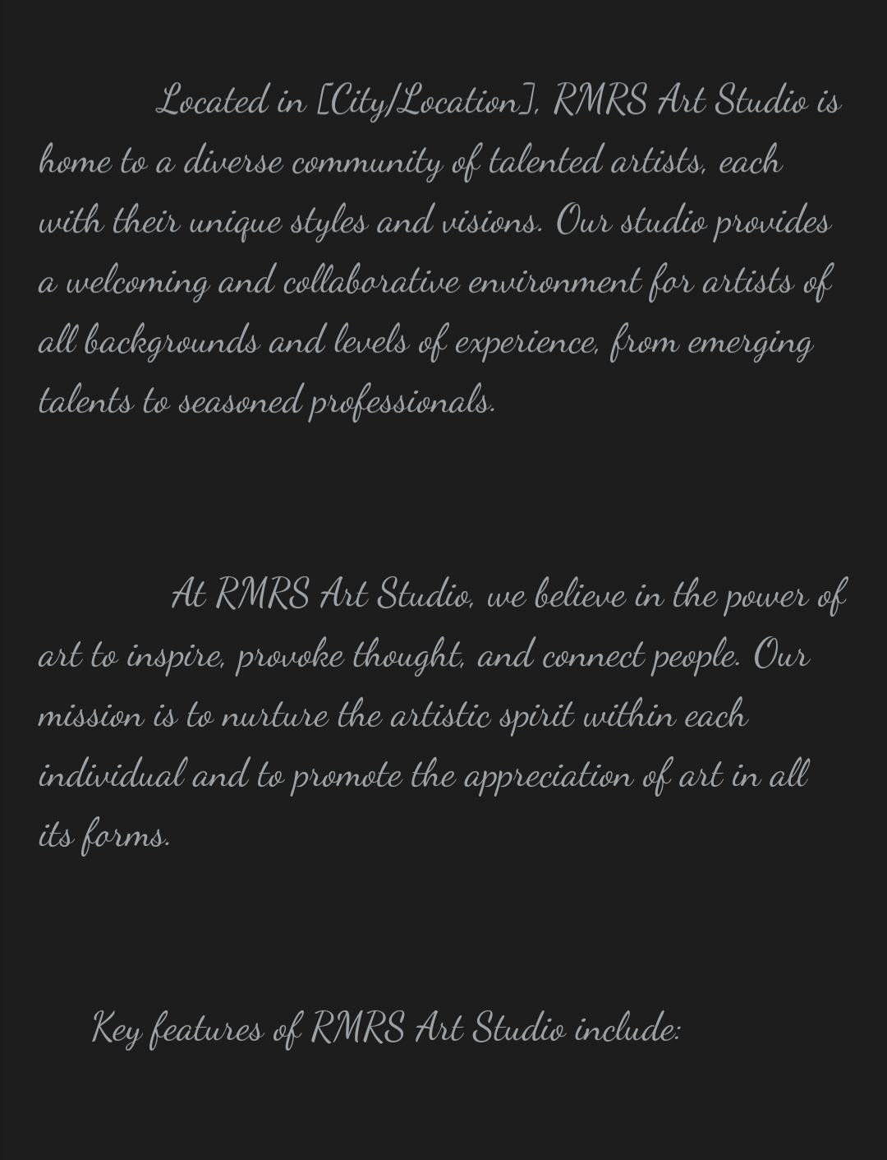

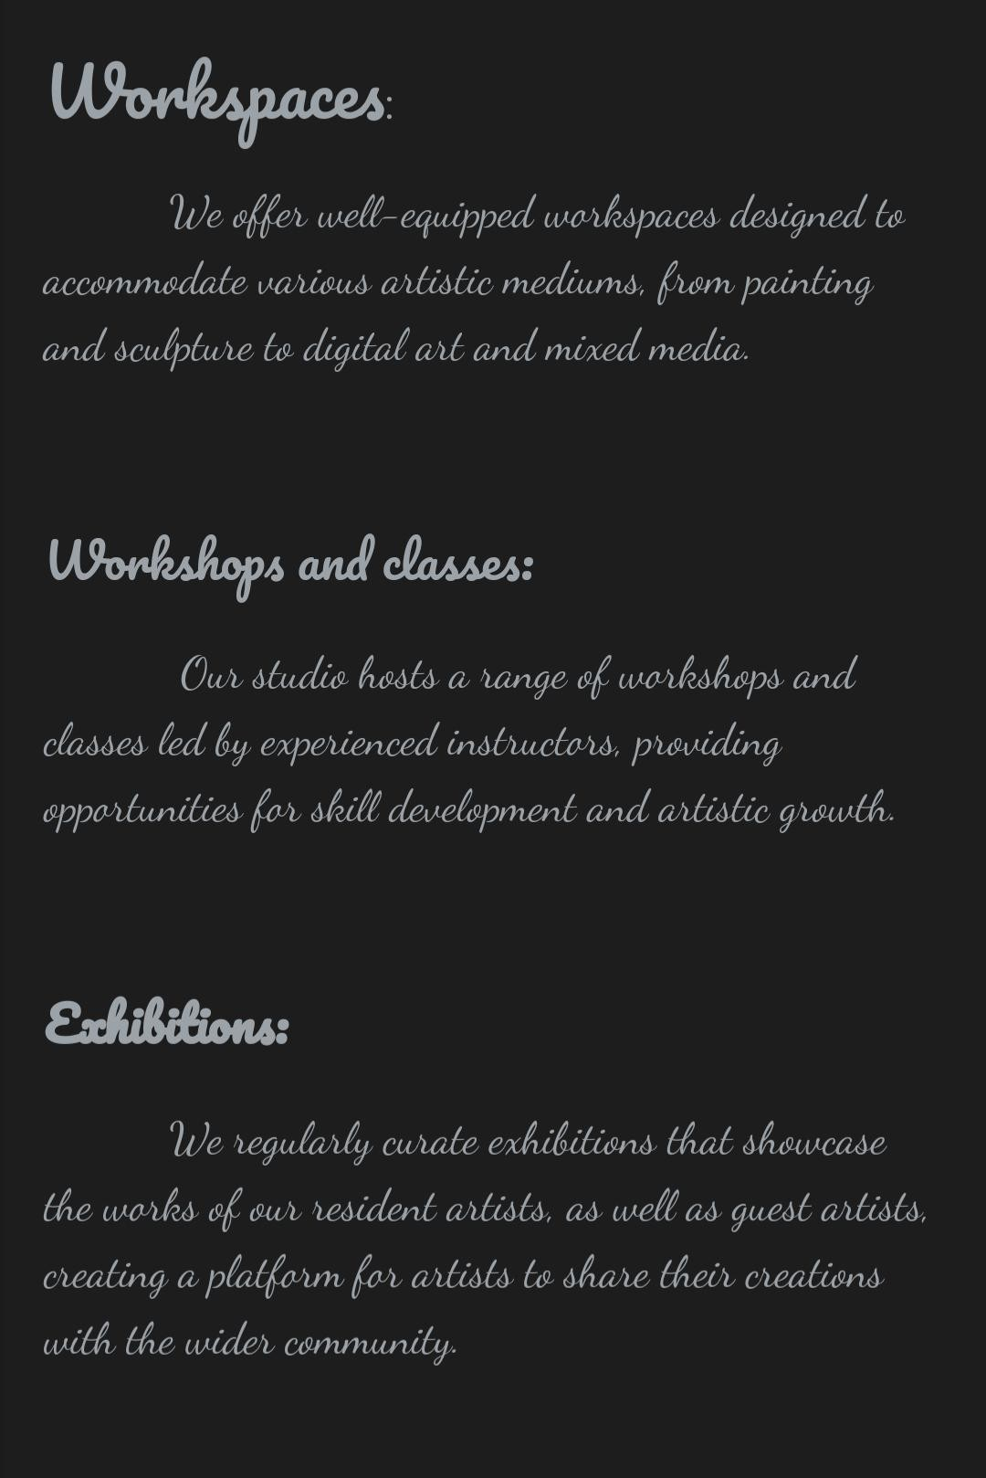

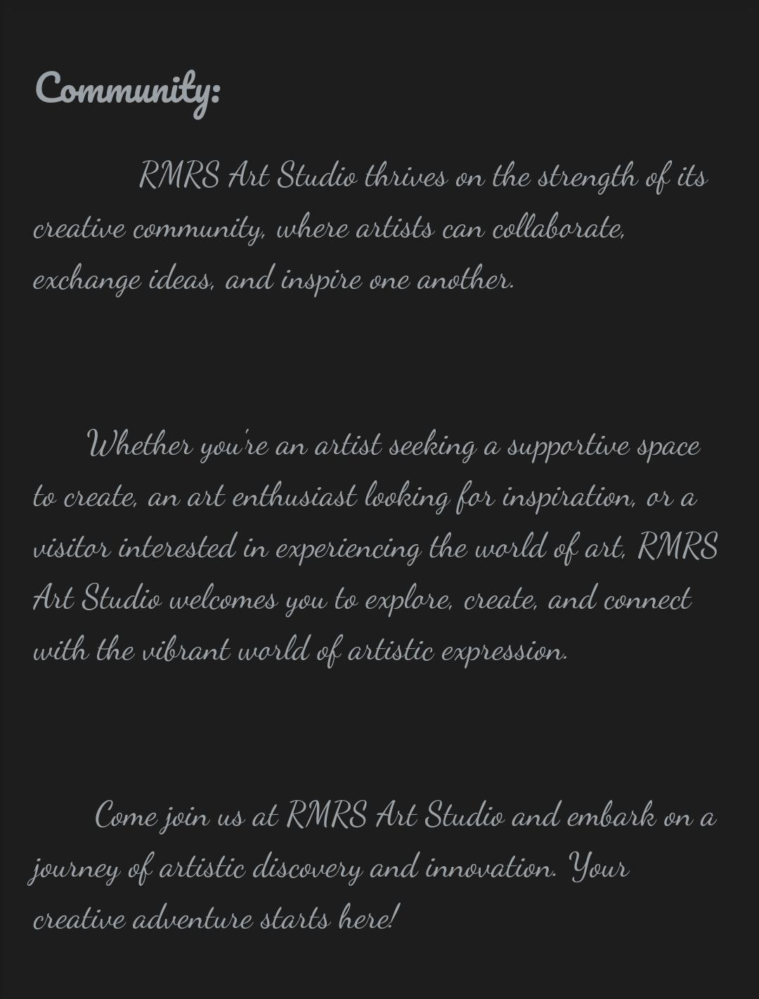

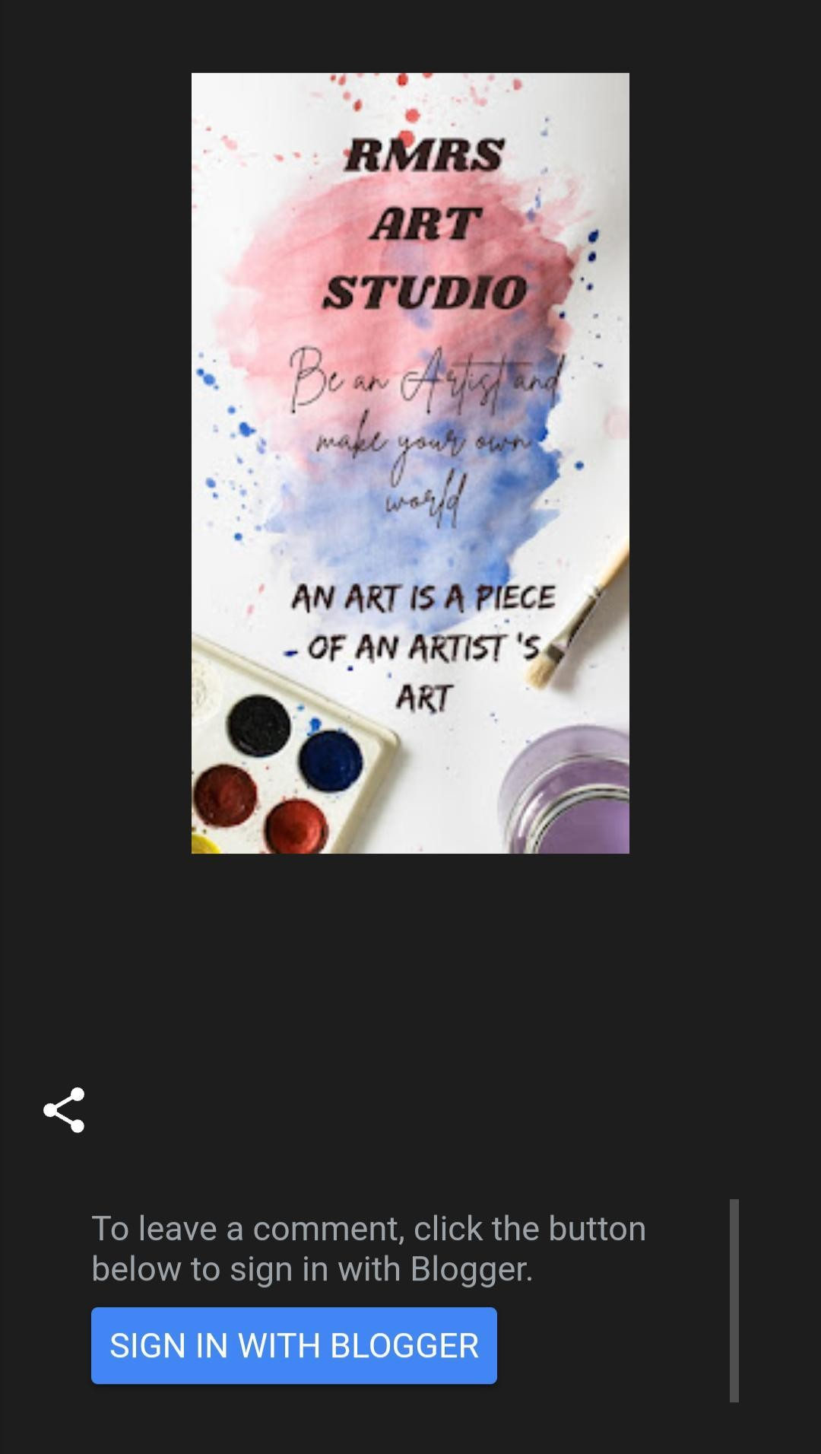

1. Create a New Facebook Business Page and post one social media poster for your brand.

Link: https://[www.facebook.com/profile.php?id=61552308112096&mibextid=ZbWKwL](http://www.facebook.com/profile.php?id=61552308112096&mibextid=ZbWKwL)

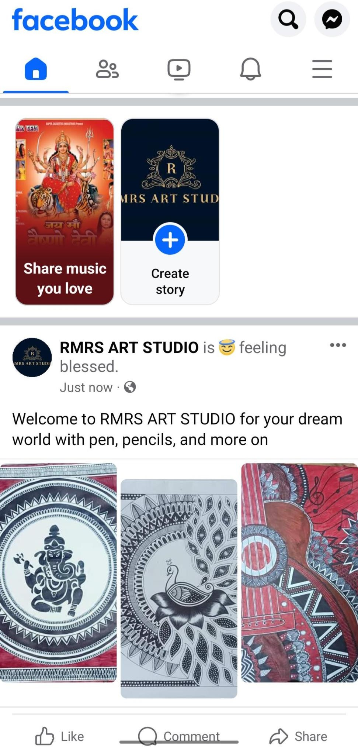



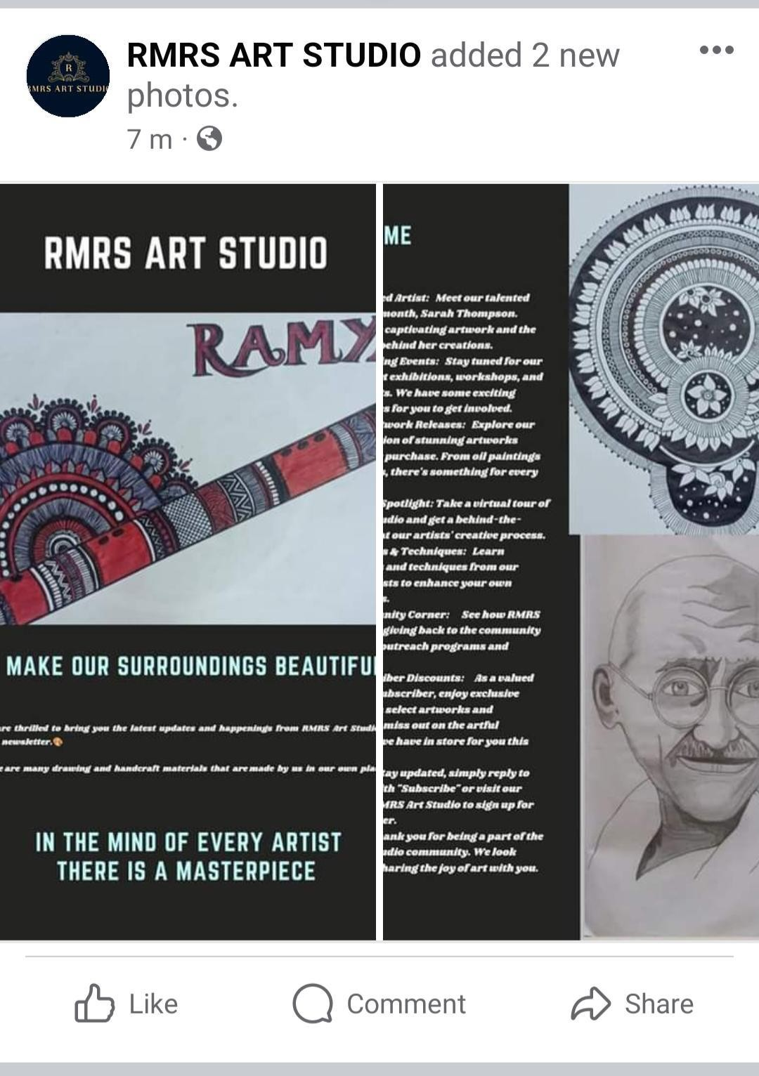

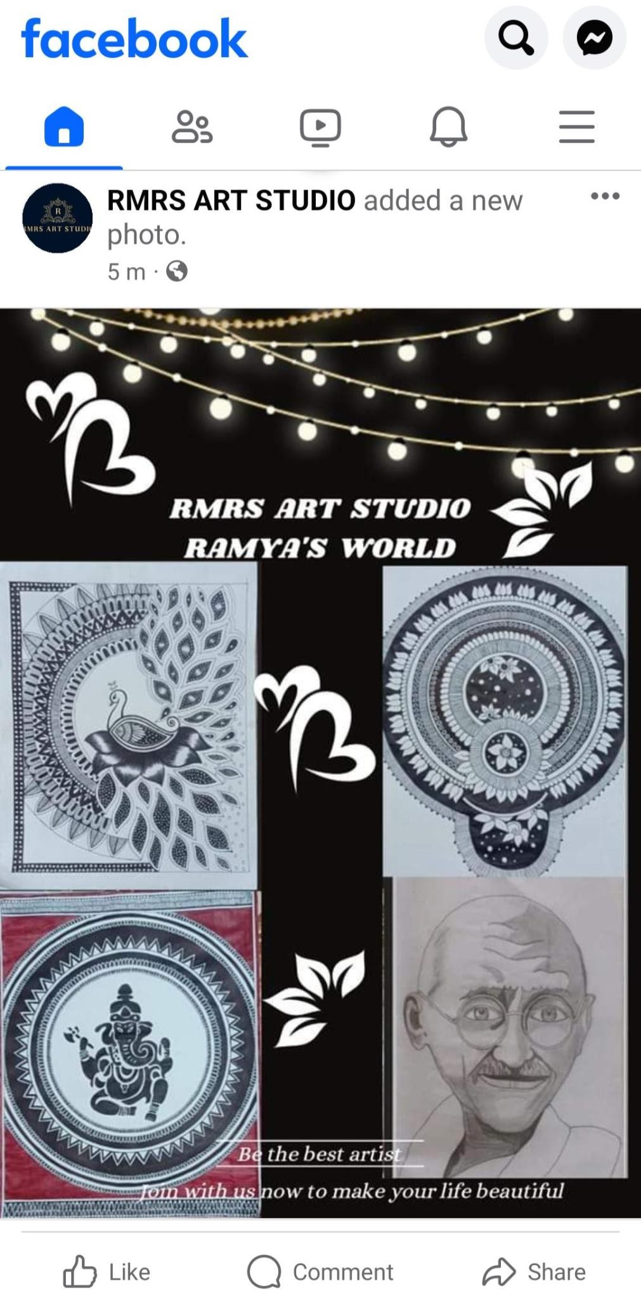

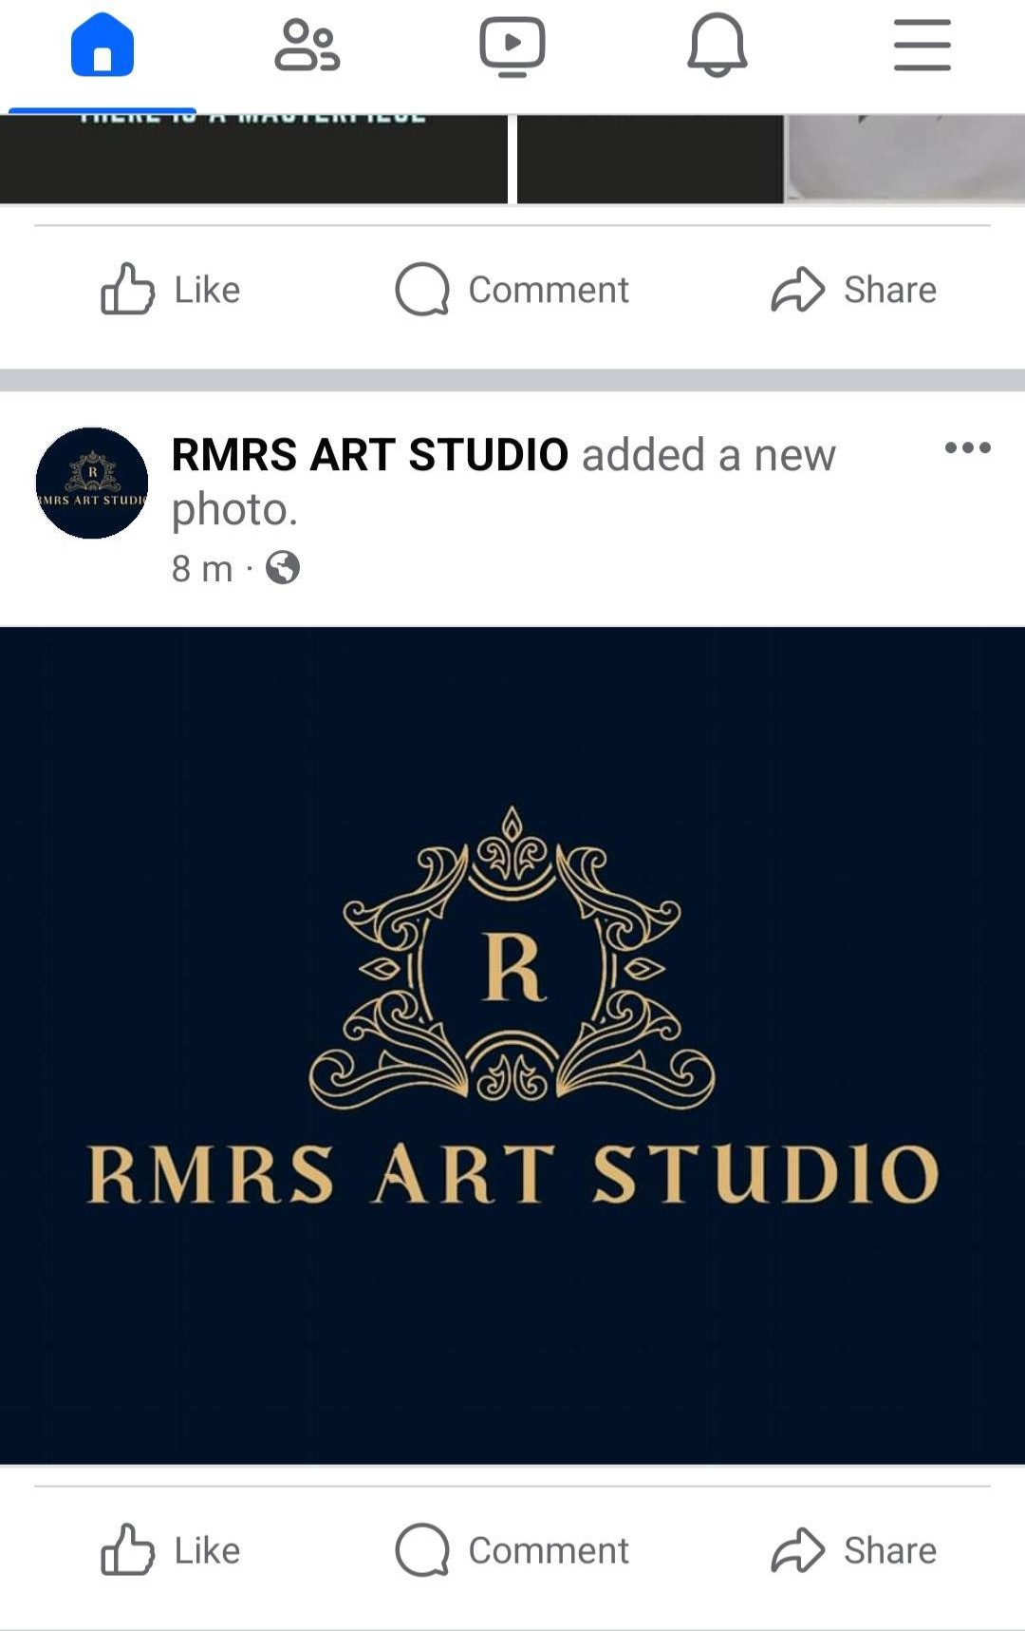

1. Create and design a social media advertisement poster using canva.

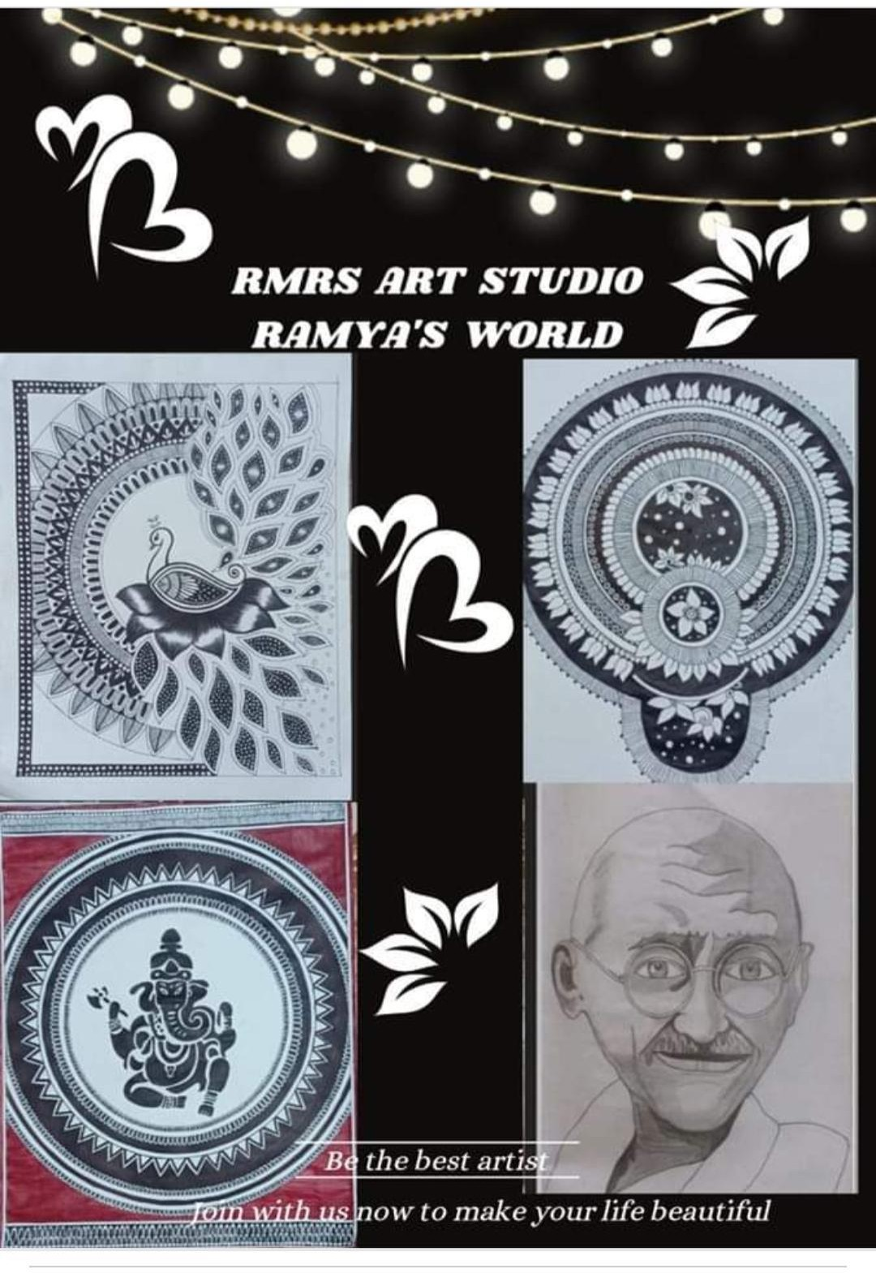

1. Create email newsletter design using MailChimp or canva tool.

Link: <https://rmrsartstudio.blogspot.com/2023/10/rmrs-srt-studio-22.html>

